Lab 7

P1: To Interface a 7 Segment LED to 8086 Microprocessor through 8255 Programmable Peripheral Controller using Proteus

Code:

|  |  |
| --- | --- |
|  |  |

Circuit Diagram:

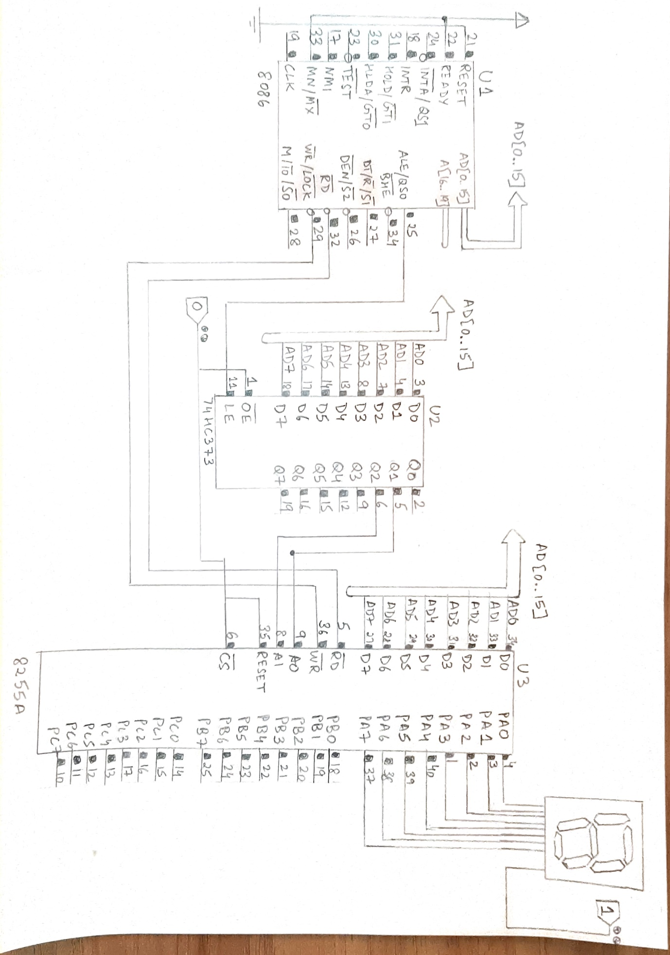

Output:

